CCI ASSIGNMENT – 2 Name: RAHUL VARMA

Roll No: S20200010212

Aim:

To prepare our state map showing future minimum temperature (tn) and maximum temperature (tx) for 2050 for RCP-8.5 using the output from any one global climate model listed in the World-clim website.

Required:

Tools:

QGIS Desktop App (<https://www.qgis.org/en/site/forusers/download.html>).

Data Taken from World Clim Website.

(<https://www.worldclim.org/data/cmip6/cmip6_clim10m.html>)

RStudio (<https://www.rstudio.com/products/rstudio/download/>)

Procedure:

From the Website World Clim the data is taken.

Navigate to Future Climate Data.

Select 10 minutes data (10 minutes means 18.5 \* 18.5 km data)

As Per Given Task we should download data for minimum temperature (tn) and maximum temperature (tx) for 2050 for RCP-8.5

Global climate model taken is EC-Earth3-Veg-LR

I have selected GCM (EC-Earth3-Veg-LR) data from 2041 to 2060 and ssp585 which is for 2050.

tn -> min temp

tx -> max temp

Once we Download the data it will be in .tif format

In order to process the data which is in tif format which is image format we need to depend on some software so we can choose QGIS which is easiest way to process the tif format files.

Two Basic Information about tif data:

It contains two types of data which is Raster data and vector data.

Raster data -> single band or multi band

Historical data is single band we can directly insert tif file in QGIS and one can analyze about it.

But Future data is in multi band we cannot directly process in QGIS.

So we need to first convert it into single band using Rstudio.

Using TinnR we can convert

.tif 🡪 .asc

Shape file is in vector data.

Tmin :

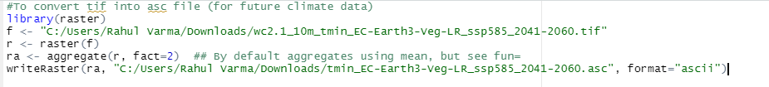

Tmax :

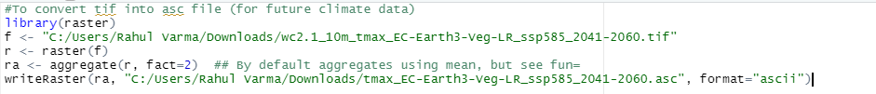

Since data which we download is raster data first insert Layer in QGIS by using add layer method.

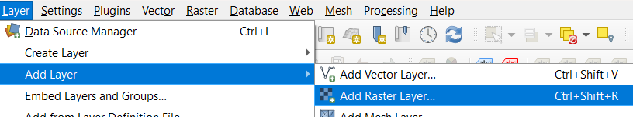

Choose the Converted .asc file for tmin

For download or interpret for specific location then we need to cut the data

We need a vector layer for doing this

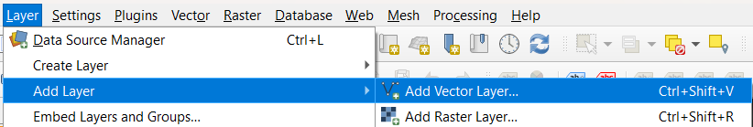

Select .shp file and add

Now we can do the Masking the data for only for specific location

i.e.. Only for Indian sub continent.

First Masking the data for india we get the picture as shown in below:

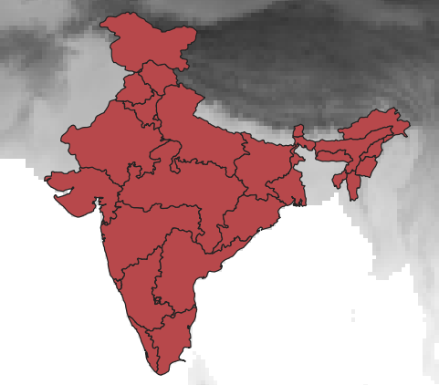

Raster:

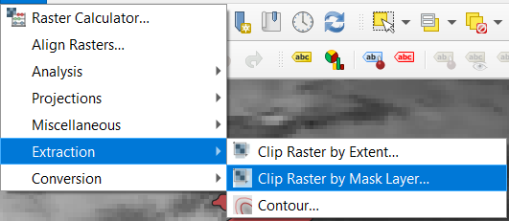

By Extracting using Raster by Mask Layer we get like this:

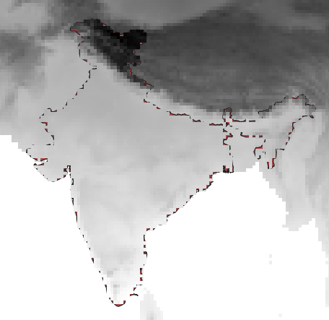

Now Select One state,

My state is Andhra Pradesh so I’m selecting Andhra Pradesh

Right click on India state merged and choose open attribute table.

And choose Andhra Pradesh.

We get the result as shown below:

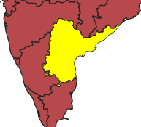

Next step is to make the shape file for only Andhra Pradesh

Select export and save the file

Only Andhra Pradesh shape file is available as shown below:

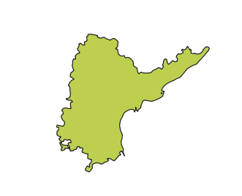

Now we can mask the min temp for only for Andhra Pradesh

The Final Output for tmin (tn) is:

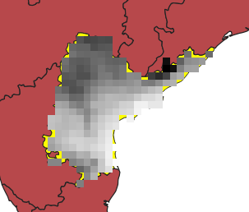

 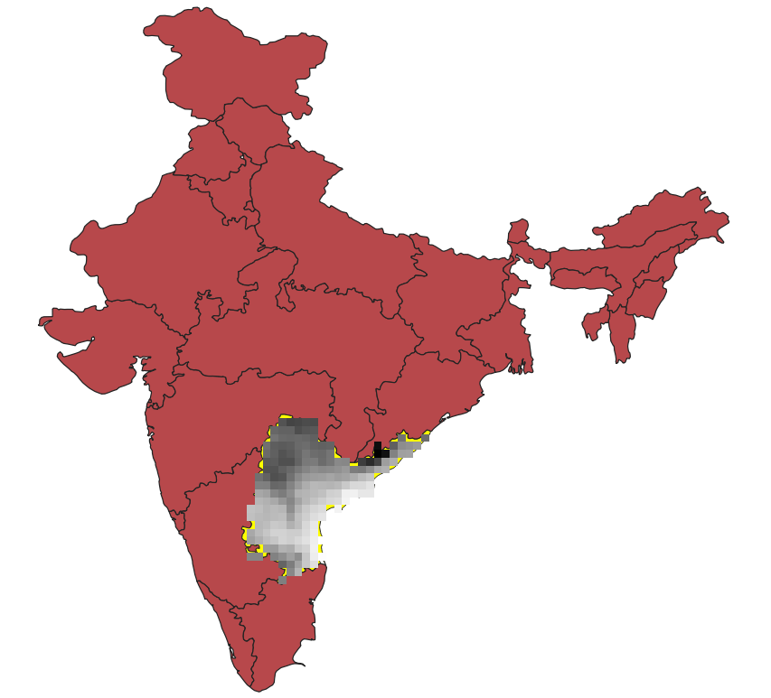

For Tmax follow the same procedure and we get the final result as shown in below:

The Final Output for tmax (tx) is:

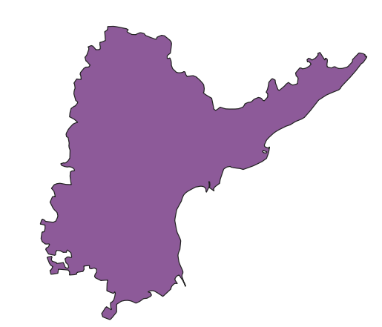

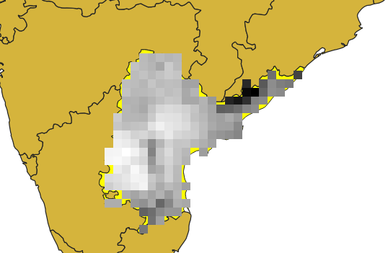

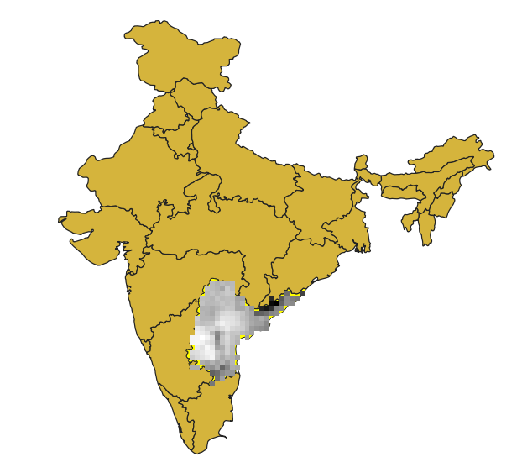

The Final Output of Tmin and Tmax for Andhra Pradesh are:

 

For Tmin (tn) For Tmax (tx)

Conclusion:

In Visakhapatnam district both Tmin and Tmax is increasing with more value when compared to other district in Andhra Pradesh same in Vizianagaram and Srikakulam.

This map is before Telangana and Andhra got divided.

So, All the Telangana districts Tmin is increased a bit but Tmax is decreased when compared to other districts.

In south districts also Tmin and Tmax are bit high.

In the other states there not much difference a very low change is observed for Tmin and Tmax for the year 2050.

So, This is my Final Observation for this Assignment.

🡨 THANK YOU 🡪